3.7综合练习

例1：一位二进制计数加七段译码电路AHDL设计如下，该设计中调用了老功能模块”4count”和七段译码器设计文件7segment.tdf。
设计源文件：
FUNCTION 4count(clk,clrn,setn,ldn,cin,dnup,d,c,b,a) %库中有此模块%
RETURNS(qd,qc,qb,qa,cout);
FUNCTION 7segment(i3,i2,i1,i0) %见前面的例题%
RETURNS(g,f,e,d,c,b,a);
SUBDESIGN 4cnt7s
(
clk,dnup :INPUT;
sa,sb,sc,sd,se,sf,sg,out,xs[3..0] :OUTPUT;
)
VARIABLE
counter : 4count;
decoder : 7segment;

BEGIN
counter.clk =clk;
counter.dnup =dnup;
decoder.i[3..0]=counter.(qd,qc,qb,qa);
xs[]=counter.(qd,qc,qb,qa);
(sg,sf,se,sd,sc,sb,sa)=decoder.(g,f,e,d,c,b,a);
out=counter.cout;
END;

该设计的仿真结果见图3.7.1。
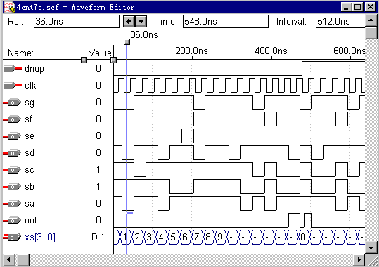

图3.7.1

例2：N位计数译码电路
四位十进制计数器AHDL设计文件(pdec9999.tdf)：
SUBDESIGN pdec9999
(
clk, ena, clrs : INPUT;
a[15..0] : OUTPUT;
)
VARIABLE
count1[3..0] : DFF;
count2[3..0] : DFF;
count3[3..0] : DFF;
count4[3..0] : DFF;
BEGIN
count1[].clk = clk;
count1[].clrn = clrs;
count2[].clk = clk;
count2[].clrn = clrs;
count3[].clk = clk;
count3[].clrn = clrs;
count4[].clk = clk;
count4[].clrn = clrs;

IF ena THEN
if count1[]==B"1001" then
count1[] =B"0000";
ELSE
count1[].d = count1[].q + 1;
END IF;
ELSE
count1[].d = count1[].q;
END IF;

IF ena THEN
if count1[]==B"1001" then
if count2[]==B"1001" then
count2[] =B"0000";
ELSE
count2[].d = count2[].q + 1;
END if;
ELSE
count2[].d = count2[].q;
end if;
ELSE
count2[].d = count2[].q;
END IF;

IF ena THEN
if count2[]==B"1001" & count1[]==B"1001"then
if count3[]==B"1001" then
count3[] =B"0000";
ELSE
count3[].d = count3[].q + 1;
end if;
ELSE
count3[].d = count3[].q;
end if;
ELSE
count3[].d = count3[].q;
END IF;

IF ena THEN
if count2[]==B"1001" & count1[]==B"1001"& count3[]==B"1001"then
if count4[]==B"1001" then
count4[] =B"0000";
ELSE
count4[].d = count4[].q + 1;
end if;
ELSE
count4[].d = count4[].q;
end if;
ELSE
count4[].d = count4[].q;
END IF;

a[3..0] = count1[];
a[7..4] = count2[];
a[11..8] = count3[];
a[15..12] = count4[];

END;

七段译码器设计文件(7segd.tdf)：
SUBDESIGN 7segd
(
i[3..0] : INPUT;
s[6..0] : OUTPUT;
)
BEGIN
TABLE
i[3..0] => s[6..0];

H"0" => B"1111110";
H"1" => B"0110000";
H"2" => B"1101101";
H"3" => B"1111001";
H"4" => B"0110011";
H"5" => B"1011011";
H"6" => B"1011111";
H"7" => B"1110000";
H"8" => B"1111111";
H"9" => B"1111011";
H"A" => B"1110111";
H"B" => B"0011111";
H"C" => B"1001110";
H"D" => B"0111101";
H"E" => B"1001111";
H"F" => B"1000111";
END TABLE;
END;

四位十进制计数并七段译码设计，该设计中调用了设计文件7segd.tdf和 pdec9999.tdf
FUNCTION 7segd(i[3..0])
RETURNS(s[6..0]);
FUNCTION pdec9999(clk,ena,clrs)
RETURNS(a[15..0]);

SUBDESIGN 4dec7sp
(
clk,ena,clrs :INPUT;
sd1[6..0],sd2[6..0],sd3[6..0],sd4[6..0] :OUTPUT;
)
VARIABLE
cntn :pdec9999;
decd1,decd2,decd3,decd4 :7segd;

BEGIN
cntn.clrs=clrs;
cntn.clk=clk;
cntn.ena=ena;
decd1.i[]=cntn.a[3..0];
decd2.i[]=cntn.a[7..4];
decd3.i[]=cntn.a[11..8];
decd4.i[]=cntn.a[15..12];
sd1[]=decd1.s[];
sd2[]=decd2.s[];
sd3[]=decd3.s[];
sd4[]=decd4.s[];
END;

该设计的仿真结果见图3.7.2：

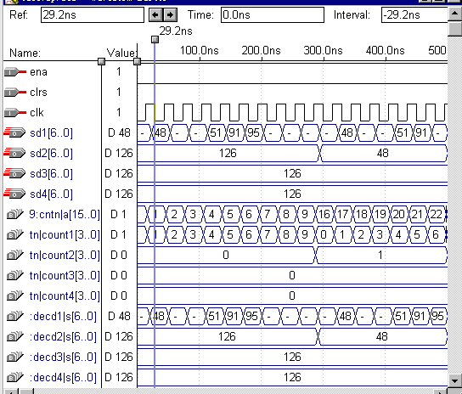
图3.7.2
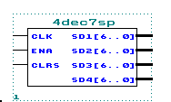该电路可以形成在图形编辑器中使用符号图3.7.3。

图3.7.3

例三：四位十进制扫描式七段译码显示设计
本设计调用了如下文件：
7segment.tdf
pdec9999.tdf
decoder.tdf
mux24.tdf
老功能模块：
4count
其中7segment.tdf(3.6 节例3)、decoder.tdf(3.6 节例7)和pdec9999.tdf(本节例2)中已经使用过了，下面列出和mux24.tdf文件。

多路选择器(mux24.tdf)文件如下：
SUBDESIGN mux24
(
sel[1..0],inp[3..0] :INPUT;
sc :OUTPUT;
)
BEGIN
if sel[]==B"00" then
sc=inp[0];
ELSIF sel[]==B"01" then
sc=inp[1];
ELSIF sel[]==B"10" then
sc=inp[2];
ELSIF sel[]==B"11" then
sc=inp[3];
END IF;
END;

四位十进制扫描式七段译码显示设计文件：
FUNCTION 7segment(i3,i2,i1,i0)
RETURNS(g,f,e,d,c,b,a);
FUNCTION pdec9999(clk,ena,clrs)
RETURNS(a[15..0]);
FUNCTION decoder(code[1..0])
RETURNS(out[3..0]);
FUNCTION mux24(sel[1..0],inp[3..0])
RETURNS(sc);
FUNCTION 4count(clk,clrn,setn,ldn,cin,dnup,d,c,b,a)
RETURNS(qd,qc,qb,qa,cout);

SUBDESIGN 47sm
(
clk,ena,clrs,clk1 :INPUT;
g,f,e,d,c,b,a,yinji[3..0]:OUTPUT;
)
VARIABLE
count4 :pdec9999;
seven :7segment;
mux1,mux2,mux3,mux4 :mux24;
count1 :4count;
yima :decoder;

BEGIN
count4.clrs=clrs;
count4.clk=clk;
count4.ena=ena;
count1.clk=clk1;
count1.clrn=!ena;
yima.code[1]=count1.qb;
yima.code[0]=count1.qa;
mux1.sel[1]=count1.qb;
mux1.sel[0]=count1.qa;
mux2.sel[1]=count1.qb;
mux2.sel[0]=count1.qa;
mux3.sel[1]=count1.qb;
mux3.sel[0]=count1.qa;
mux4.sel[1]=count1.qb;
mux4.sel[0]=count1.qa;
mux1.inp[0]= count4.a[0];
mux1.inp[1]= count4.a[4];
mux1.inp[2]= count4.a[8];
mux1.inp[3]= count4.a[12];
mux2.inp[0]= count4.a[1];
mux2.inp[1]= count4.a[5];
mux2.inp[2]= count4.a[9];
mux2.inp[3]= count4.a[13];
mux3.inp[0]= count4.a[2];
mux3.inp[1]= count4.a[6];
mux3.inp[2]= count4.a[10];
mux3.inp[3]= count4.a[14];
mux4.inp[0]= count4.a[3];
mux4.inp[1]= count4.a[7];
mux4.inp[2]= count4.a[11];
mux4.inp[3]= count4.a[15];
seven.i[0]=mux1.sc;
seven.i[1]=mux2.sc;
seven.i[2]=mux3.sc;
seven.i[3]=mux4.sc;
g=seven.g;
f=seven.f;
e=seven.e;
d=seven.d;
c=seven.c;
b=seven.b;
a=seven.a;
yinji[3..0]=yima.out[3..0];
END;

该四位十进制扫描式七段译码显示的仿真结果见图3.7.4。
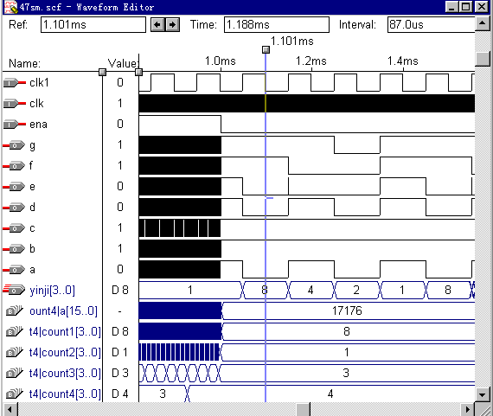

图3.7.4

